Email
First Name
Last Name
Contact Number
Role – choose from
Dean
Chair of DSC
Secretary of DSC
Member of DSC
Clergy (including deacons) not DSC members
Religious (not DSC members)
Other:
Parish Name & Town
Deanery – please indicate
Liverpool Central
Liverpool North
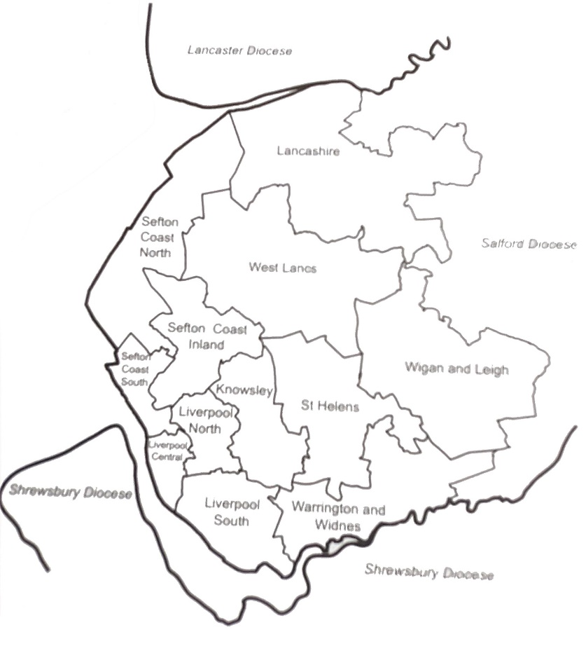
Liverpool South
Isle of Man
Knowsley
Lancashire
St Helens
Sefton Coast North
Sefton Coast South
Sefton Inland
Warrington & Widnes
West Lancs
Wigan & Leigh
Other or not known
Parish Centers
We will be holding our formation sessions at various parish centers across the archdiocese. There are links via google maps to the location of the parish centers below. You are asked to register for a session that best serves you for location and date.

Please register for one of the following evening events by indicating which session you can attend. Each event will run from 7 - 9pm.
Where possible, please could Chairs and Deans of the same deanery register for the same evening. *

1. Tuesday, 20 September: Widnes at St Basil & All Saints Parish Centre
2. Wednesday, 28 September: Netherton, Bootle at Our Lady of Walsingham Parish Centre
3. Friday, 30 September: Wigan at St Jude's Parish Centre
4. Wednesday, 5 October: Chorley at St Joseph's Harper's Lane Parish Centre
5. Friday 7 October: Croxteth at Our Lady Queen of Martyrs Parish Centre
6. Thursday 13 October: St Helens at St Anne and Bl Dominic Parish Centre
Please send this completed registration back to pd@rcaol.org.uk
at least 5 working days before the session you wish to attend.

